https://github.com/agabaemmanuel611-dev/group-23-coursework.git

Group 23: Campus Food Delivery and Order Management System
Faculty: Science and Technology

Course Code & Title: 1203 ST- PROGRAMMING FUNDAMENTALS

Group Number: Group 23

1. System Overview & Architecture
The Campus Food Delivery and Order Management System is a console-based Python program designed to digitize ordering, fee calculation, rider tracking, and sales reporting for a campus canteen.
- Menu Structure: Stores menu items in three categories (Meals, Drinks, Snacks) mapped to item numbers, names, and prices in UGX.
- Order Processing: Builds customer shopping carts, validates item quantities, and calculates delivery fees using conditional balance tiers (0 UGX for totals ≥30,000 UGX, 1,500 UGX for totals ≥ 15,000 UGX, and 3,000 UGX for smaller orders).
- Rider Assignment: Assigns riders sequentially using modulo arithmetic on order counts.
- Data Persistence: Reads and writes order records to orders.json via the Path library and json module, handling file creation and corrupt file errors safely.

2. Group Work Division
Group Member | Primary Module / Contribution | Code Responsibilities
Gordon Brighton | Menu Setup & Data Setup | Defined initial menu dictionary structure and default rider/status lists.
Kirabo Mercynitah | File Persistence & Data I/O | Implemented load_orders() and save_orders() with JSON exception handling.
Garang Machar | Menu Interface | Developed show_menu() to format and print item categories and pricing.
Asaba Emmanuel | Input Helpers & Logic | Wrote lookup helper find_item() and input validator get_valid_integer().
Ababa Emmanuel | Cart Building | Constructed item selection loop and interactive cart array inside add order().
Lule Alex | Fee & Order Calculation | Programmed delivery fee logic, order ID generation, rider assignment, and total calculation.
Ssekamate Hassan | Status Tracking | Developed order lookup and status update routing (change_status).
Atulinda Patrah Kamara | Order Status Management | Co-developed order status transition workflow and confirmation prints.
Katongole Ibrahim | Revenue & Sales Metrics | Built total revenue and order status counters in show_report().
Isaac Ngise | Sales Analytics | Programmed item quantity counters and best-selling item calculation.

3. Challenges & Technical Solutions
- File Corruption & Missing Data:
  - Challenge: Missing or corrupted JSON logs would cause standard Python file readers to crash.
  - Solution: Wrapped loading logic in try-except blocks (FileNotFoundError, json.JSONDecodeError) to safely default to a clean state.
- Input Validation:
  - Challenge: Non-integer or negative inputs during quantity entry produced program errors.
  - Solution: Integrated a while validation loop in get_valid_integer() to enforce positive whole numbers.
- Automated Rider Distribution:
  - Challenge: Uniformly distributing orders across delivery riders without manual selection.
  - Solution: Used modulo indexing len(orders) % len(riders) to cycle rider assignments automatically.
SCREENSHOTS OF THE OUTPUT

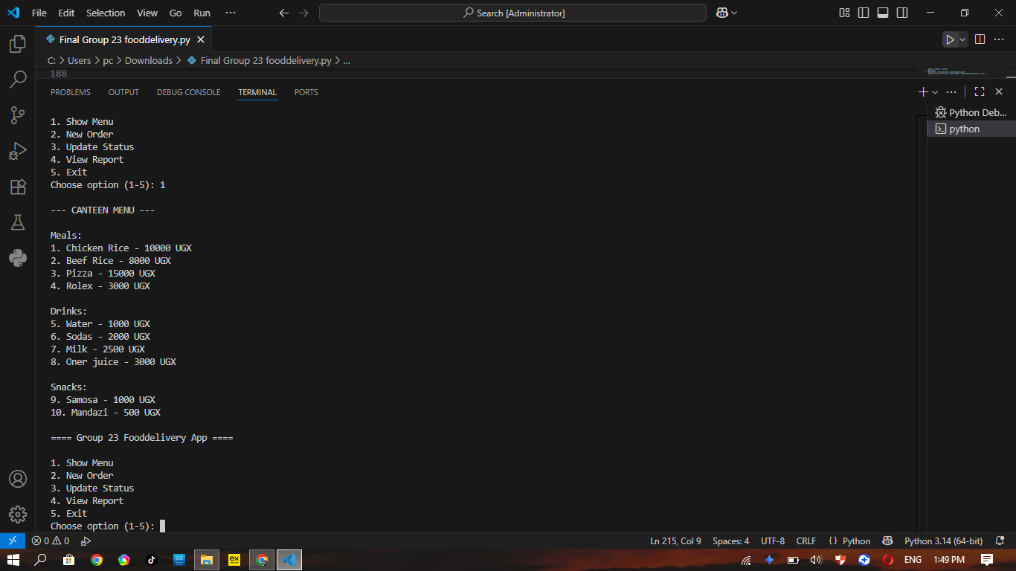
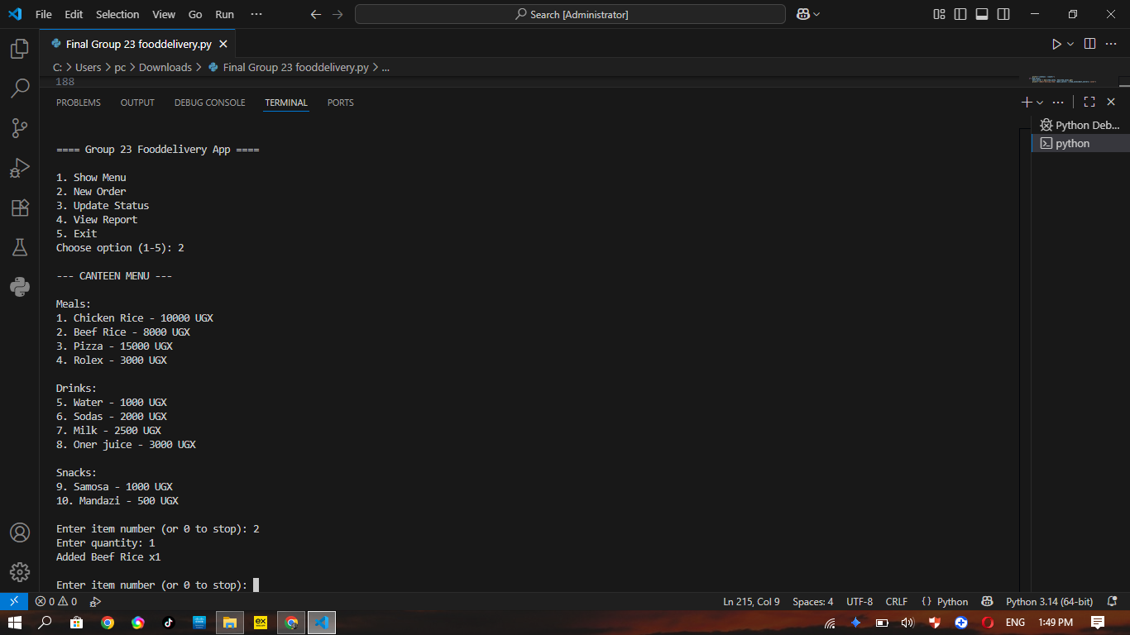
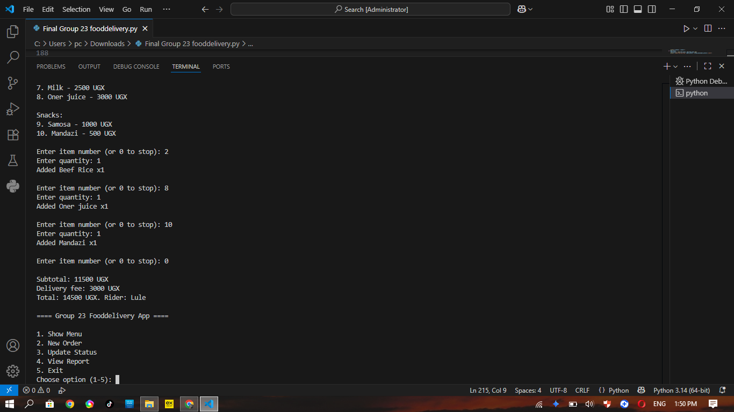
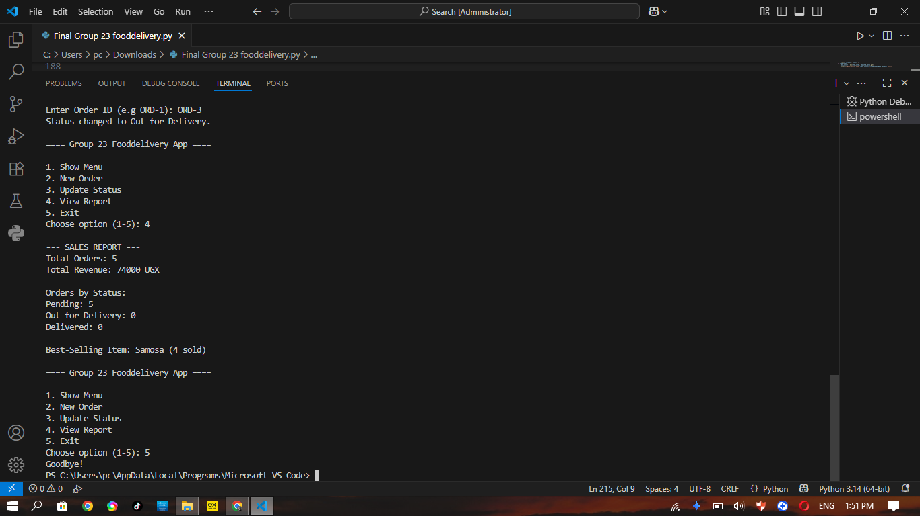

https://github.com/agabaemmanuel611-dev/group-23-coursework.git

